CONVERT NUMBERS TO WORDS AND DIGITS
KS1 – 2016 Paper - Reasoning
1.
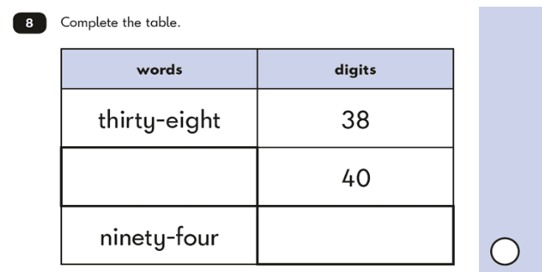
KS1 – 2016 Paper – Reasoning (Second)
2.

